**Project B: Swimming shark with some magical shapes**

Name: Hong Hong NetID: hha7337

**User guide**

The goal of this project is to get familiar with adjustable cameras and quaternion manipulation.

Upon opening the project webpage, user can see a shark that swims continuously and a magical under-water grass that swings upon the gird. There are also some moving shapes in the canvas. User can press “WASD”keys to move around the camera location, W/S for moving forwards and backwards and A/D for moving left and right. User can also press “JKIL”keys to look around the scene, J/L keys to look left and right, and I/K keys to look up and down. User can also use mouse to drag and spin the sphere in the scene. I did not realized the whole function but the html code of slider bar for six frustum parameters, therefore, the camera may not change when user drag the slider bar.

**Result**

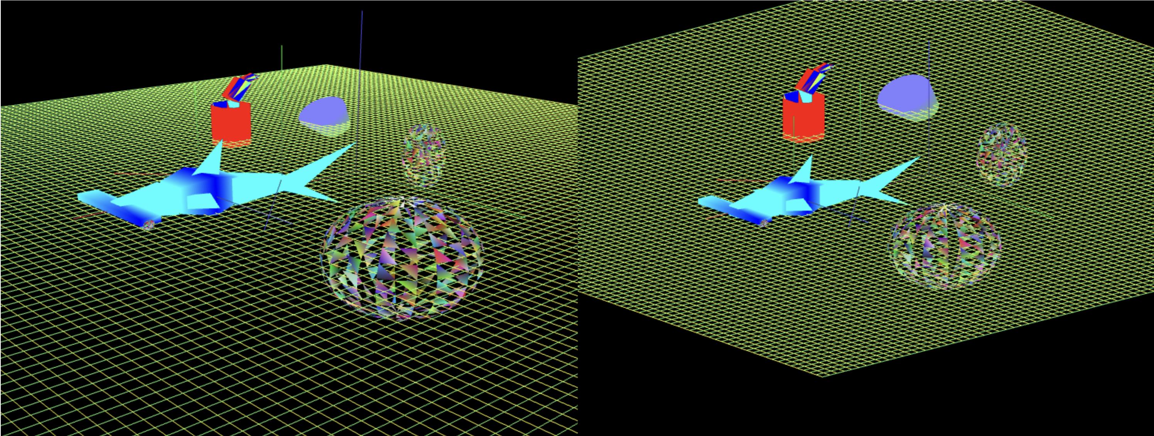

Figure a: original view

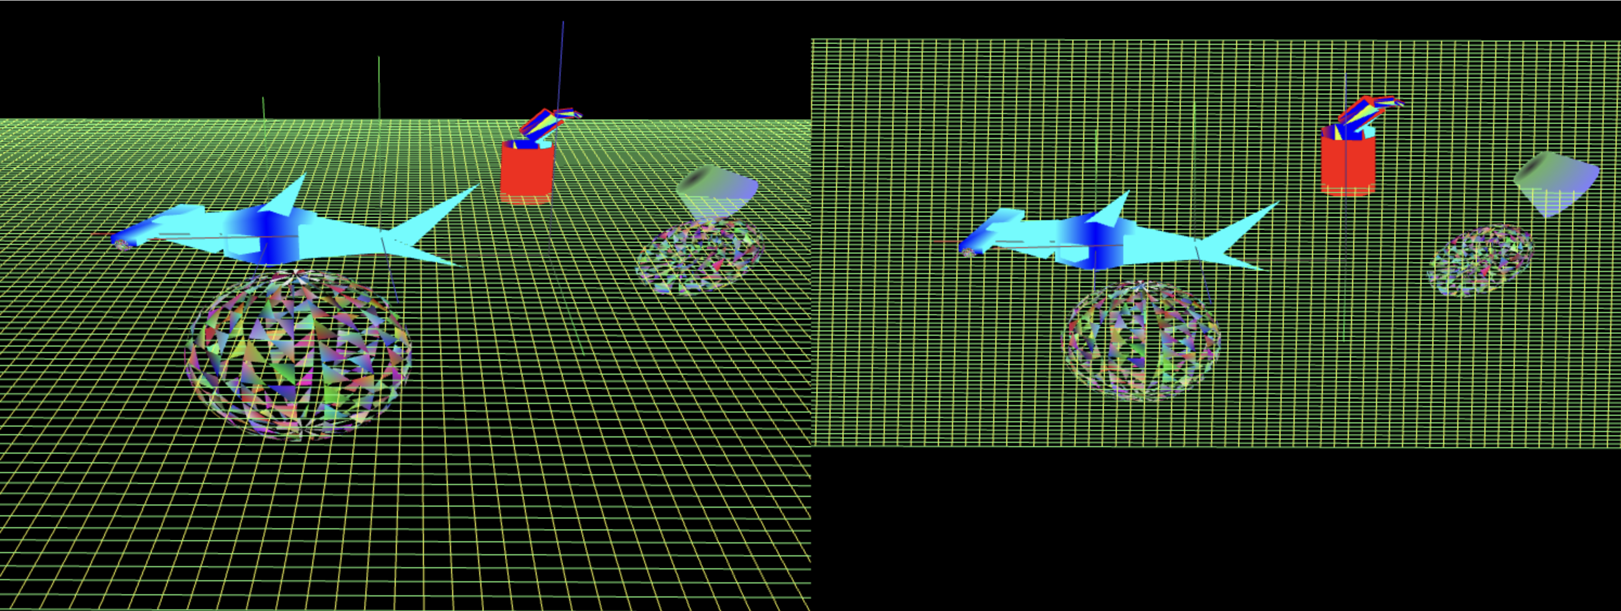

Figure b: Right view

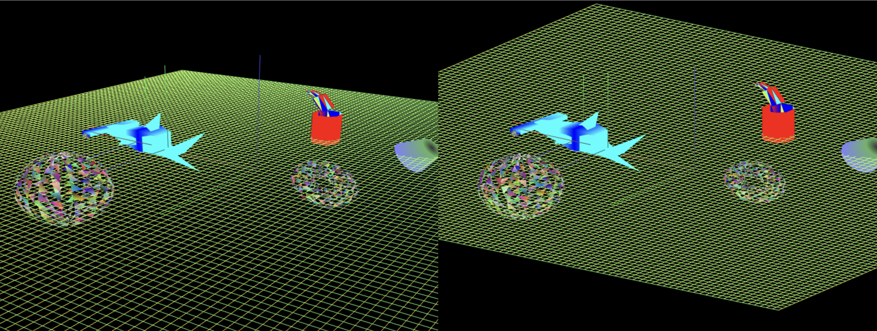

Figure c: Back view

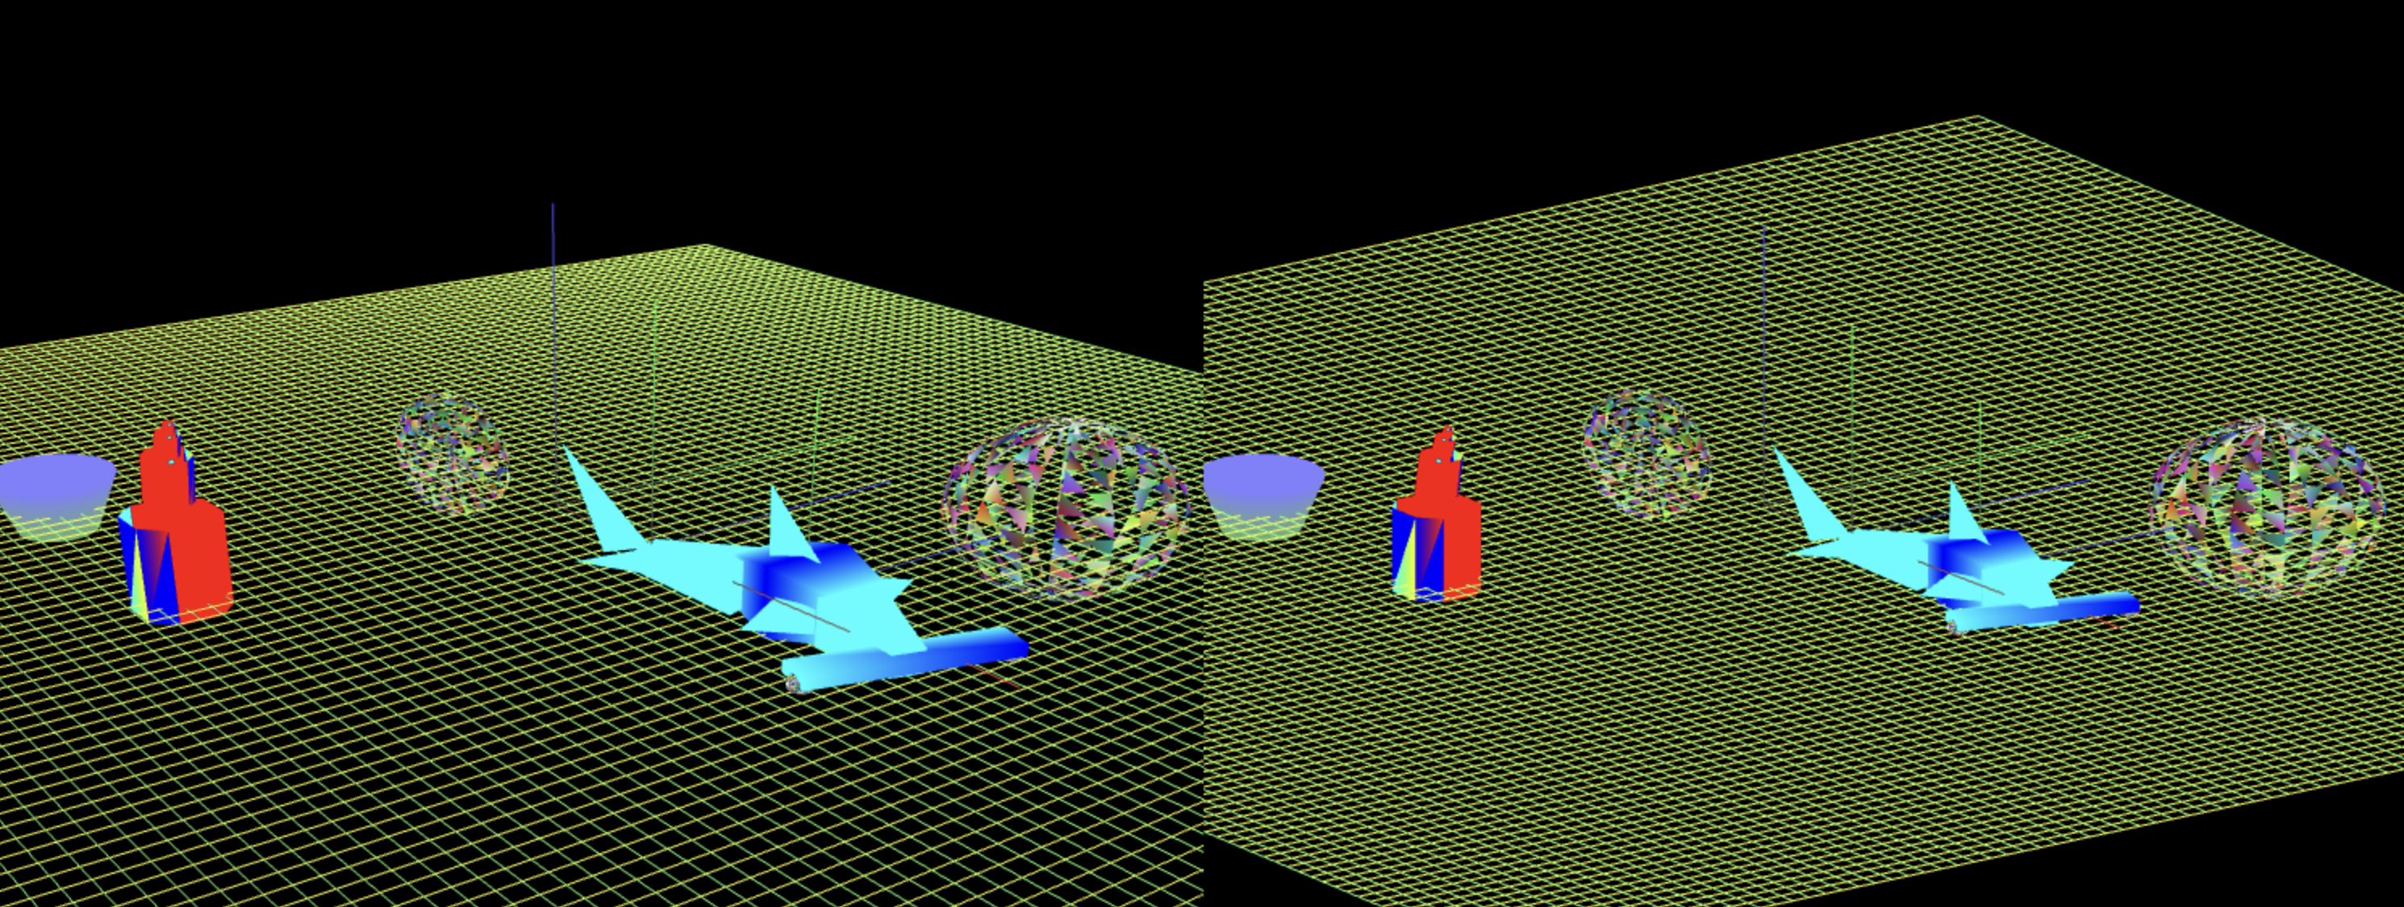

Figure d: Left view

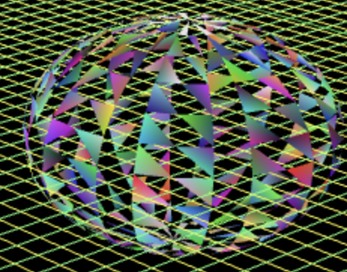 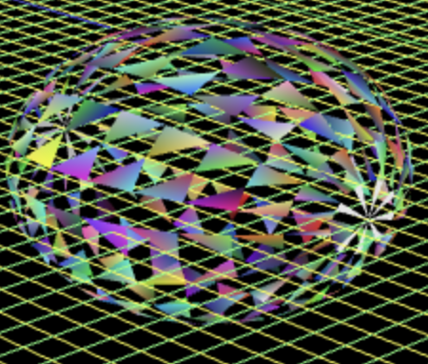

Figure e: Original sphere Figure f: Sphere after spinning

**Below is the scene graph:**

